|  |  |
| --- | --- |
|  |  |

**Estudo Dirigido Prova**

Exercício 100) 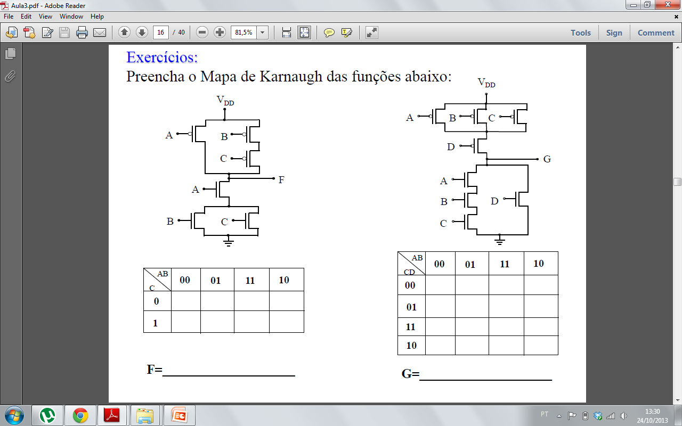

Exercício 2) Implemente as funções abaixo, utilizando a ténica de associação série/ paralelo apresentado em sala de aula: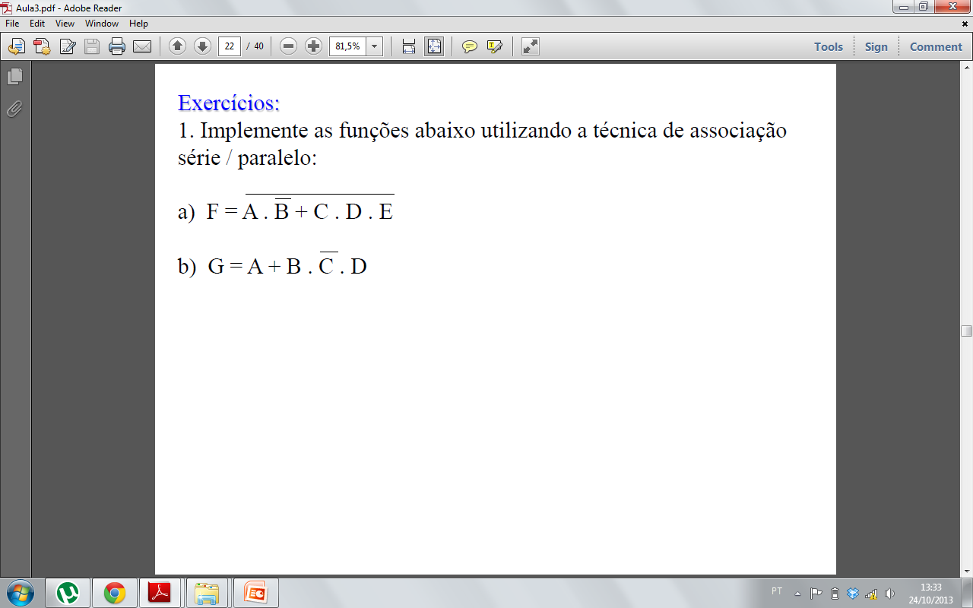

Exercício 3) Para o circuito abaixo, pede-se:

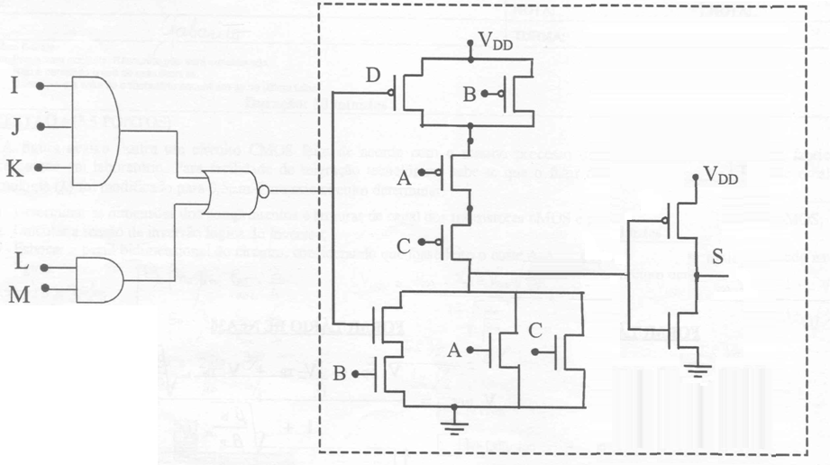

a) Determinar a expressão da função S, em função dos sinais de entrada (A,B,C e D);

b) Desenhar o circuito representado por portas lógicas, utilizando-se da técnica de associação série- paralelo.

1. Complete a tabela expandida e reduzida do Latch Nor : **(2,0 pontos)**

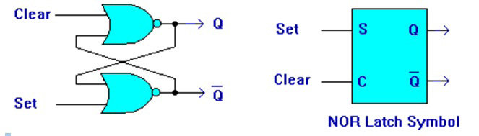

|  |  |  |  |  |  |  |  |  |  |  |  |  |  |  |  |  |  |  |  |  |  |  |  |  |  |  |  |  |  |  |  |  |  |  |  |  |  |  |  |  |  |  |  |  |  |  |  |  |  |  |  |  |  |
| --- | --- | --- | --- | --- | --- | --- | --- | --- | --- | --- | --- | --- | --- | --- | --- | --- | --- | --- | --- | --- | --- | --- | --- | --- | --- | --- | --- | --- | --- | --- | --- | --- | --- | --- | --- | --- | --- | --- | --- | --- | --- | --- | --- | --- | --- | --- | --- | --- | --- | --- | --- | --- | --- |
| |  |  |  |  | | --- | --- | --- | --- | | S | C | Qn | Qn+1 | | 0 | 0 | 0 |  | | 0 | 0 | 1 |  | | 0 | 1 | 0 |  | | 0 | 1 | 1 |  | | 1 | 0 | 0 |  | | 1 | 0 | 1 |  | | 1 | 1 | 0 |  | | 1 | 1 | 1 |  | | |  |  |  | | --- | --- | --- | | S | C | Qn+1 | | 0 | 0 |  | | 0 | 1 |  | | 1 | 0 |  | | 1 | 1 |  | |  |

1. Qual a simbologia de um Latch Nor?